Maths reasoning questions

Hint: column method
- 366 + 567 =

- 876 + 234 =

- 986 + 342 =

- 546 + 986 =

Hint: add the 0

- 12 x 10 =

- 45 x 100 =

- 87 x 1000 =

Can you solve the following sums and write the inverse?

- 3 x 5 =

- 6 x 7 =

- 9 x 8 =

- 8 x 4 =

- 32 x 2 =

Can you solve these questions and explain your answer?

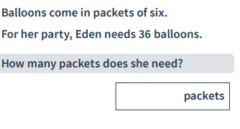

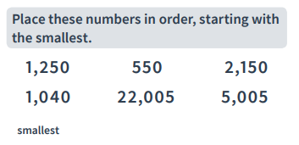

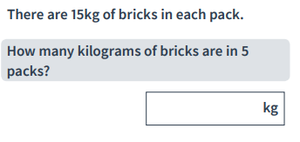

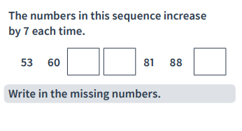

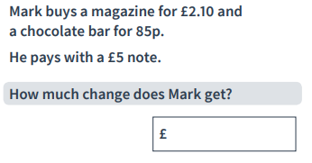

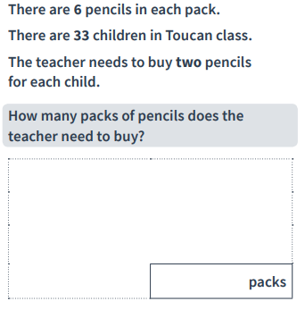

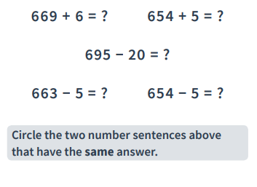

- Can you show the inverse of this sum?
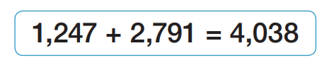

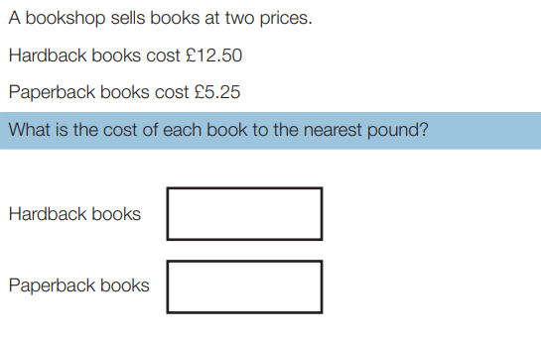

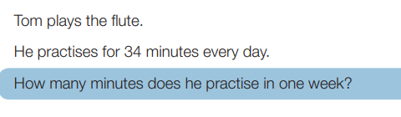

- What number is halfway between 18 and 24?

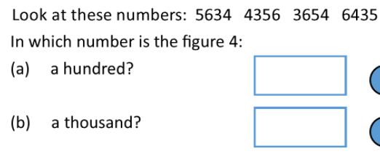
- Write the number 2345 in words

