Science Spring Revision Pack

- This is a complete circuit.

True False

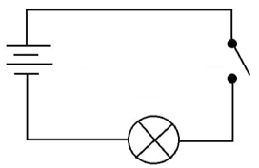
A
2.
C

B

Which letter is pointing to the bulb?
A

B

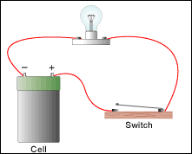
C

3. What is the job of a switch in a circuit?

____________________________________________________________________________________________________________________________________________________________________________________________________________________________________________________________________________________

4. Look at the picture. What are the main dangers that you can see?
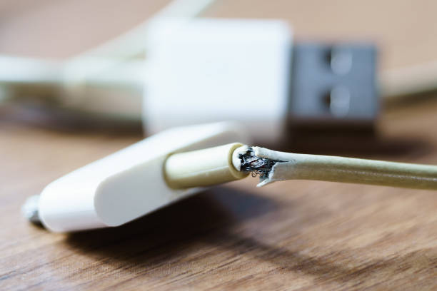

____________________________________________________________________________________________________________________________________________________________________________________________________________________________________________________________________________________

5. Complete the labels in the diagram.
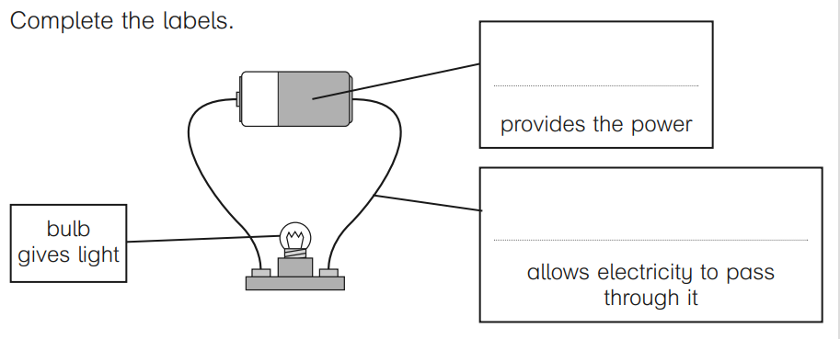

6. Match each component to the correct symbol. One has been done for you.

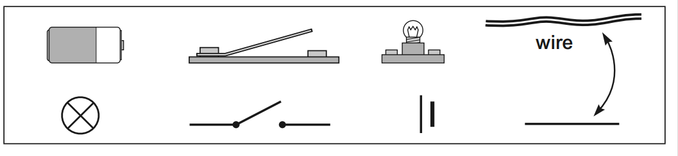

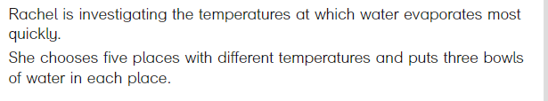
7.

a) What variable will Rachel change in this test?
__________________________________________________________________________________________________________________________________________
b) Why does Rachel put three bowls of water in each place?
__________________________________________________________________________________________________________________________________________

8. Miss Lauren is wanting to complete an investigation on the best way to melt ice cubes. What is the best way for her to record her results?

Make a table
Write a sentence
Use the iPad to take a picture
Write a mathematical calculation

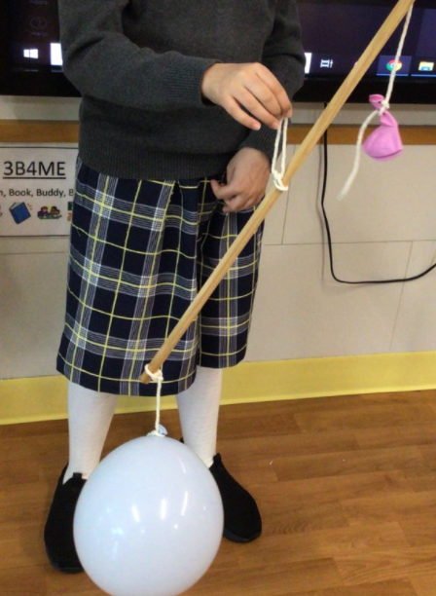
9. What was the aim of the investigation below?
_____________________________________________
_____________________________________________
_____________________________________________
_____________________________________________
_____________________________________________
_____________________________________________
_____________________________________________
_____________________________________________

10. Look at the table. At 11:00, the temperature was the highest.

True False

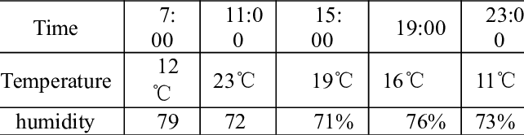

11. Look at the table. At 19:00, the temperature was the lowest.

True False

11. What do all objects have in common?
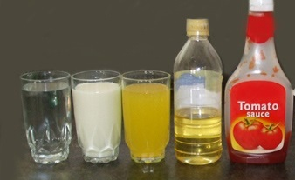

______________________________________________________________________________________________________________________________________________________________________________________________________________________________________________________________________________________________________________________________________________________________________________________________________________________________

12. How does a chocolate change from a solid to a liquid?




